Online materials
metafor/Rを使ったメタアナリシス
「診療ガイドラインのためのGRADEシステム（第2版）」（相原、凸版メディア、2015年出版）のオンライン追加資料です。http://www.grade-jpn.com/online_supplementals/online_supplemental_materials.html

- 詳細は書籍の4.4.3章を参照ください。
- 本資料のファイル名：Metafor_heparin.docx （相原守夫、2014年9月作成）
- 以下の内容は、更新される可能性がありますので、上記URLに表示する年月日を参考にしてください。

R： version 3.0.3
データ： heparin4metafor.xlsx (heparin.RData)
##Rを立ち上げ、インストールしたmetaforを読みこむ
データを読みこむ。
- ディレクトリの変更（データのある場所を指定）
- Rコマンダーを使って、（この例では、データ名を“heparin”に指定し）、エクセルデータを読みこむ（csvか、テキストデータでも可）。
- もしくは、R console に、 >dat <- get(heparin)
##データを表示
>heparin
>print(heparin[,-c(8:9)], row.names=FALSE)

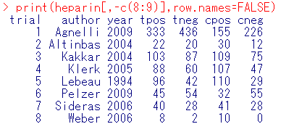

### meta-analysis of the log relative risks using a random-effects model
> dat = escalc(measure="RR", ai=tpos, bi=tneg, ci=cpos, di=cneg, data=heparin, append=TRUE)
> res <- rma(yi, vi, data = dat)
> res
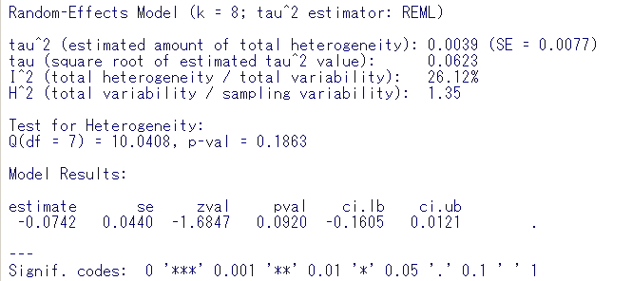

> confint(res)
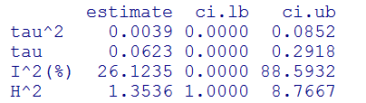
###log odds-ratio
>res <- rma(measure="OR", ai=tpos, bi=tneg, ci=cpos, di=cneg, slab=paste(author, year, sep=", "), data=heparin)
>res
（結果略）

###forest plot
>forest(res)
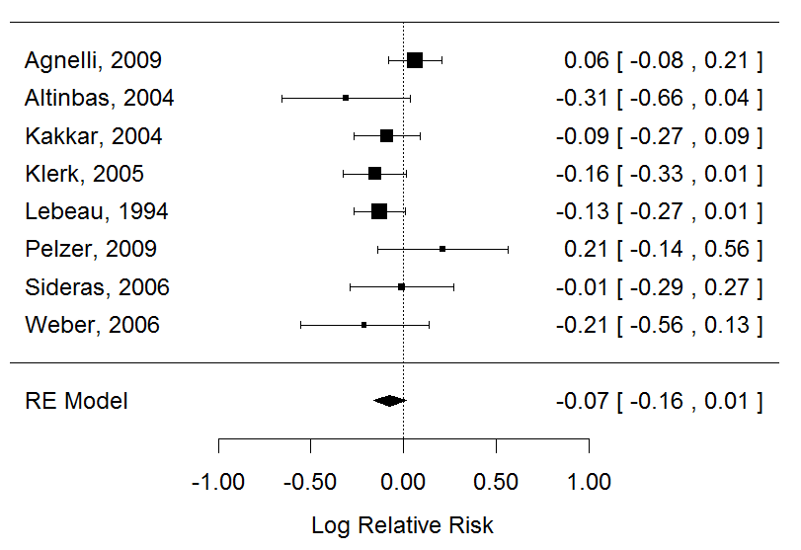

>forest(res, slab = paste(heparin$author, heparin$year, sep = ", "), xlim = c(-16, 6), at = log(c(0.05, 0.25, 1, 4)), atransf = exp, ilab = cbind(heparin$tpos, heparin$tneg, heparin$cpos, heparin$cneg), ilab.xpos = c(-9.5, -8, -6, -4.5), cex = 0.9)

>op <- par(cex = 0.75, font = 2)
> text(c(-9.5, -8, -6, -4.5), 10, c("outcome+", "outcome-", "outcome+", "outcome-"))
> text(c(-8.75, -5.25), 11, c("Heparin", "Control"))
> text(-16, 10, "Author(s) and Year", pos = 4)
> text(6, 10, "Relative Risk [95% CI]", pos = 2)
> par(op)

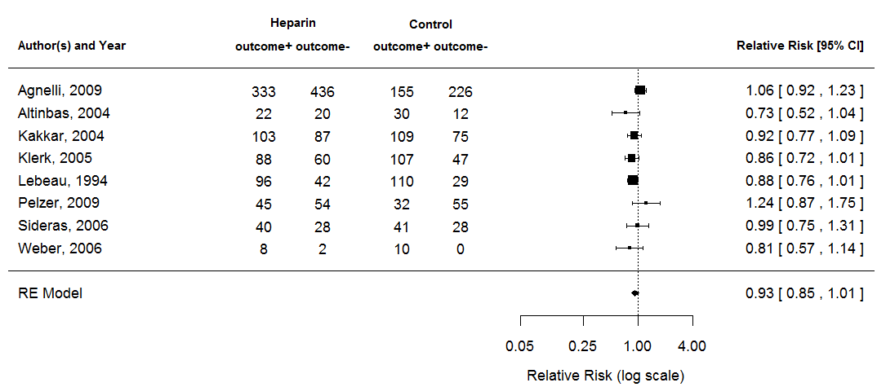

###forest plot (pooled estimates by control rate)
>forest(dat$yi, dat$vi, atransf = exp, ylim = c(-3.5, 16),at = log(c(0.05, 0.25, 1, 4, 20)), xlim = c(-9, 7),slab = paste(dat$author, dat$year, sep = ", "))
>res <- rma(yi, vi, mods = cbind(controlrate), data = dat)
> preds <- predict(res, newmods = c(0.4, 0.6, 0.8))
> addpoly(preds$pred, sei = preds$se, atransf = exp,mlab = c("controlrate 0.4", "controlrate 0.6", "controlrate 0.8"))
> text(-9, 15, "Author(s) and Year", pos = 4, font = 2)
> text(7, 15, "Relative Risk [95% CI]", pos = 2, font = 2)
> abline(h = 0)
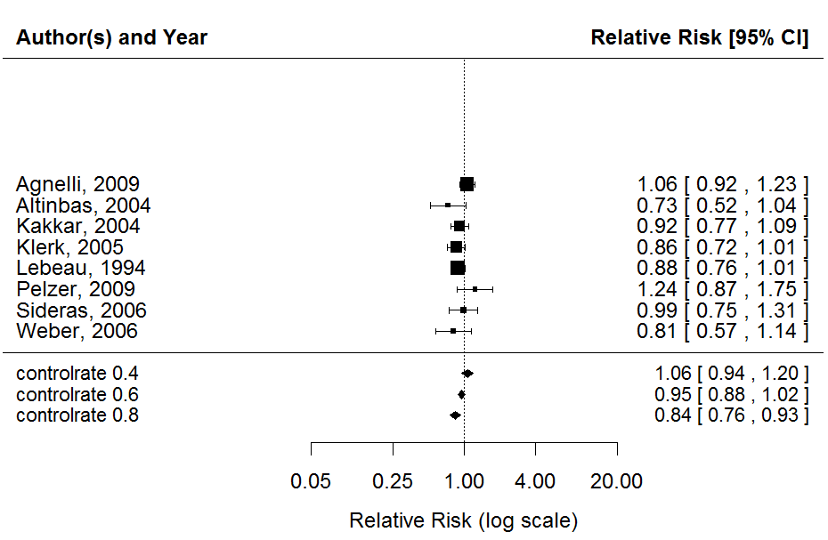

##funnel plot (Random-effects model without moderators)
> res <- rma(yi, vi, data = dat)
> funnel(res, main = "Random-Effects Model")
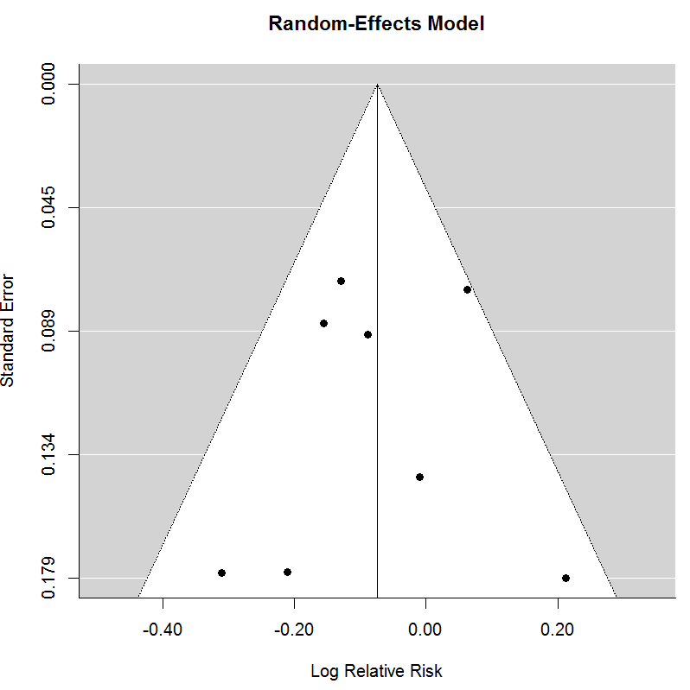

##funnel plot (mixed-effects model with moderators: modulator as controlrate)
>res <- rma(yi, vi, mods = cbind(controlrate), data = dat)
>funnel(res, main = "Mixed-Effects Model")

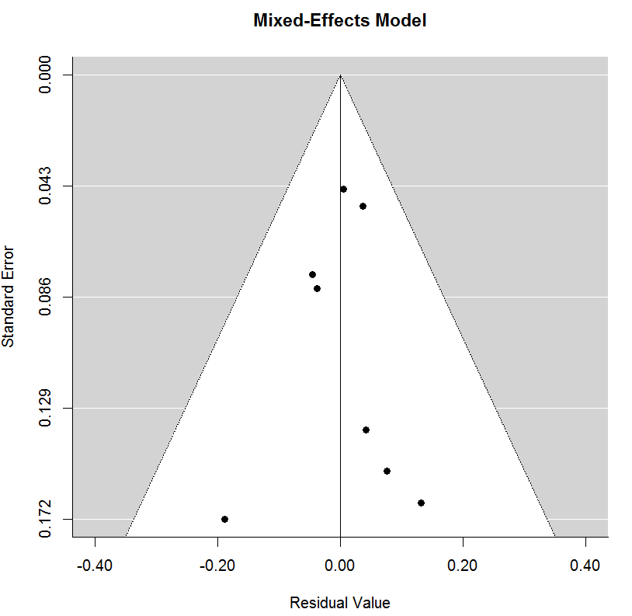

### contour-enhanced funnel plot centered at 0 (see Peters et al., 2008)
>funnel(res, level=c(90, 95, 99), shade=c("white", "gray", "darkgray"),refline=0, atransf=exp, at=log(c(.25, .5, 1, 2, 4)))

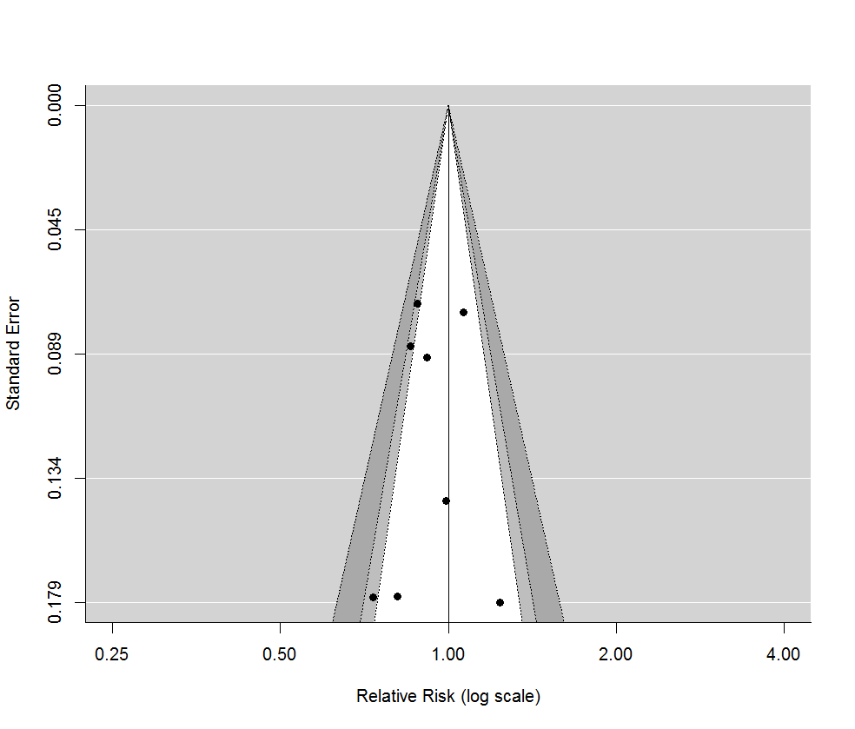

### classical Egger test
> regtest(res, model="lm")
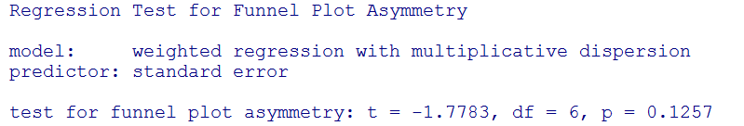

###Fail-Safe N Analysis (File Drawer Analysis)
>fsn(yi, vi, data=dat)
>fsn(yi, vi, data=dat, type="Orwin")
>fsn(yi, vi, data=dat, type="Rosenberg")

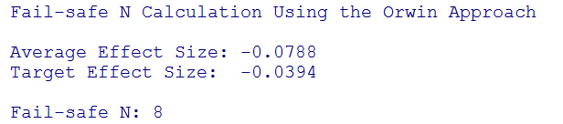

###Trim-and Fill
> res <- rma(measure="RR", ai=tpos, bi=tneg, ci=cpos, di=cneg, slab=paste(author, year, sep=", "), data=heparin)
>res.tf <- trimfill(res)
>res.tf
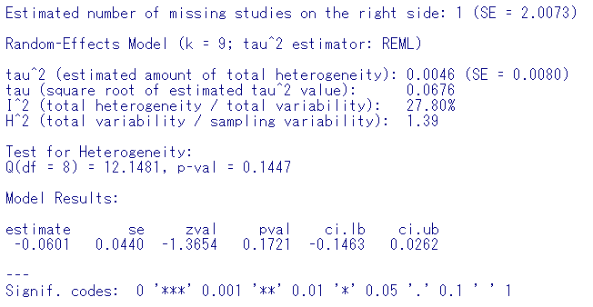

>funnel(res.tf)
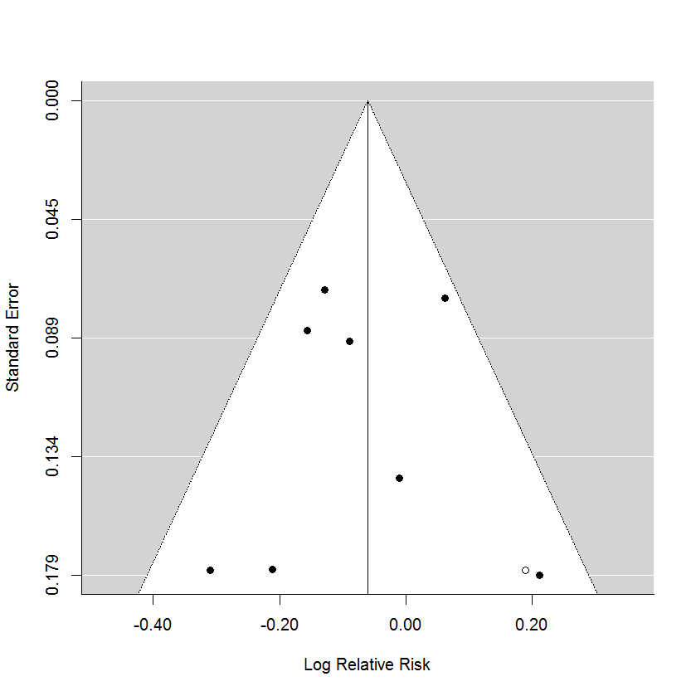

###Galbraith plot
> res <- rma(yi, vi, data = dat, method = "FE")
> radial(res, main = "Fixed-Effects Model")
> res <- rma(yi, vi, data = dat, method = "REML")
> radial(res, main = "Random-Effects Model")
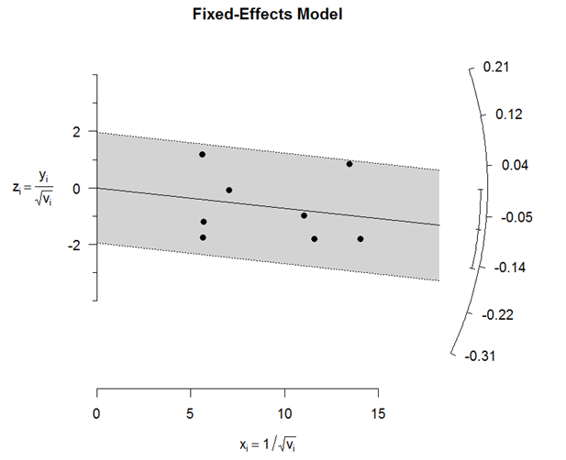

### L'Abbe plot
>labbe(res, transf=transf.ilogit, bg="white", xlim=c(0.2,0.6), ylim=c(0.2,0.6), xlab="Control Group Risk", ylab="Intervention Group Risk")
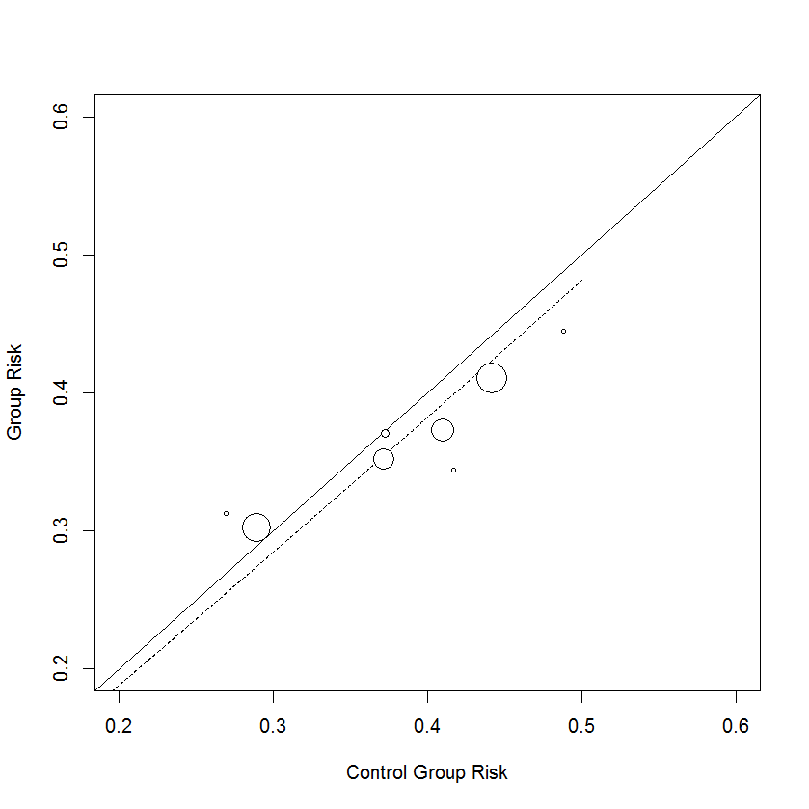

### Subgroup analysis（がんの種類によるサブ解析）
> dat = escalc(measure="RR", ai=tpos, bi=tneg, ci=cpos, di=cneg, data=heparin, append=TRUE)
> res <- rma(yi, vi, data = dat)

>forest(res, slab = paste(heparin$author, heparin$year, sep = ", "), xlim=c(-16, 6), at=log(c(.05, .25, 1, 4)), atransf=exp, ilab = cbind(heparin$tpos, heparin$tneg, heparin$cpos, heparin$cneg), ilab.xpos=c(-9.5,-8,-6,-4.5), cex=.75, ylim=c(-1, 27), order=order(heparin$cancertype), rows=c(18:13,8:7), mlab="RE Model for All Studies")

> op <- par(cex=.75, font=4)
text(-16, c(19.5,9.5), c("non-SCLC", "SCLC"), pos=4)
par(font=2)

>text(c(-9.5,-8,-6,-4.5), 21, c("Event+", "Event-", "Event+", "Event-"))
text(c(-8.75,-5.25), 22, c("Heparin", "Control"))
text(-16, 21, "Author(s) and Year", pos=4)
text(6, 21, "Relative Risk [95% CI]", pos=2)
par(op)
>res <- rma(measure="RR", ai=tpos, bi=tneg, ci=cpos, di=cneg, data=heparin,
subset=(cancertype==”non-_sclc”))
addpoly(res, row=11.5, cex=.75, atransf=exp, mlab="RE Model for Subgroup")

>res <- rma(measure="RR", ai=tpos, bi=tneg, ci=cpos, di=cneg, data=heparin,
subset=(cancertype==”sclc”))
addpoly(res, row=5.5, cex=.75, atransf=exp, mlab="RE Model for Subgroup")

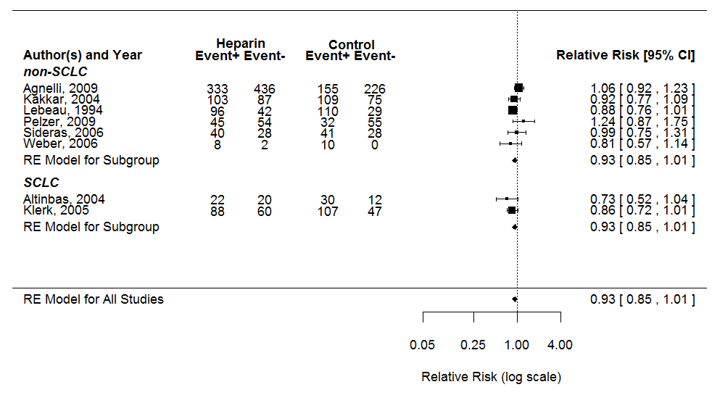

###メタ回帰（yi, viを利用。共変量としてcontrolrate）
> metaReg =rma(yi, vi, mods=~controlrate, data=dat)
>metaReg
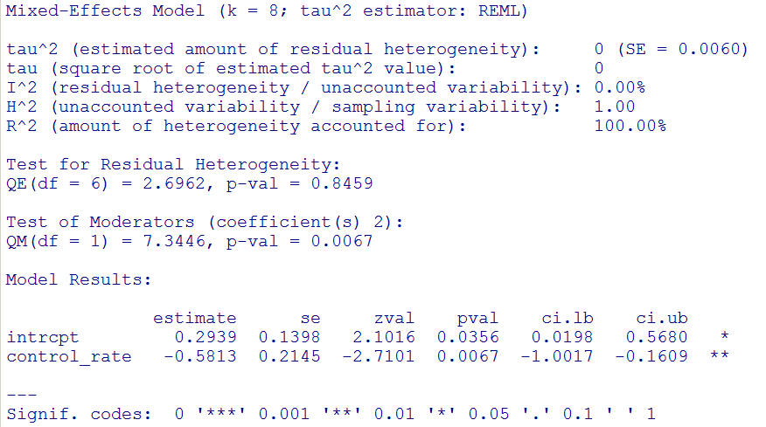

##メタ回帰（生データを利用。共変量＝controlrateとしてpredict）
>res <- rma(measure="RR", ai=tpos, bi=tneg, ci=cpos, di=cneg, mods = ~ controlrate, data=dat)
> predict(res, transf=exp, addx=TRUE)

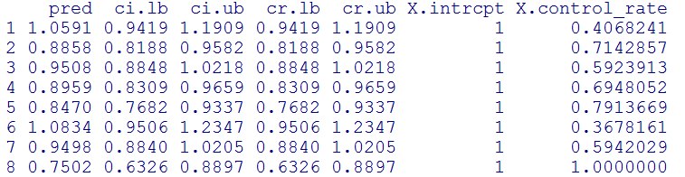

### predicted average relative risks for 0.2-1.0 controlrate
（本資料のp3, ###forest plot (pooled estimates by control rate)を参照）

>predict(res, newmods = seq(from = 0.2, to = 1.0, by = 0.2),transf = exp, addx = TRUE)

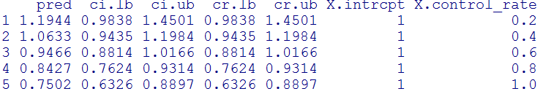

###回帰曲線
>preds <- predict(res, newmods = (0:1), transf = exp)
>wi <- 1/sqrt(dat$vi)
> size <- 0.5 + 3 * (wi - min(wi))/(max(wi) - min(wi))
>plot(dat$controlrate, exp(dat$yi), pch = 19, cex = size,xlab = "controlrate", ylab = "Relative Risk",las = 1, bty = "l", log = "y")

#Add a thicker line for the meta-regression and the CIs
>lines(0:1, preds$pred)
>lines(0:1, preds$ci.lb, lty = "dashed")
>lines(0:1, preds$ci.ub, lty = "dashed")
>abline(h = 1, lty = "dotted")

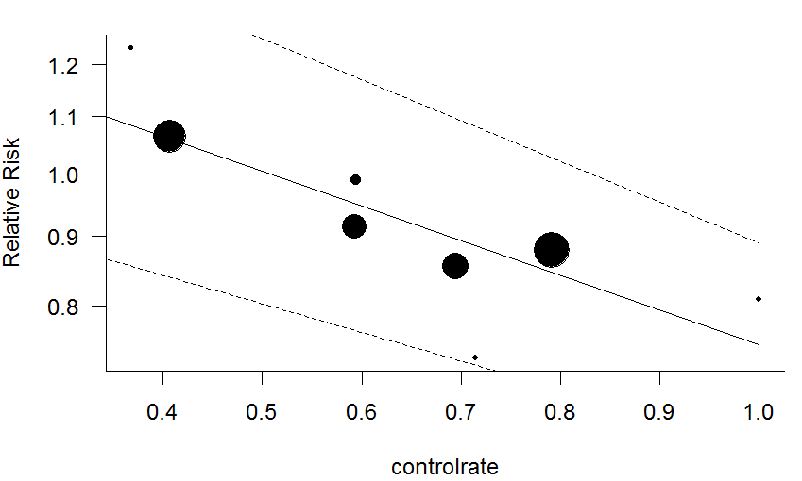

### influence analysis
> inf <- influence(res)
> inf

> plot(inf, plotdfb = TRUE)

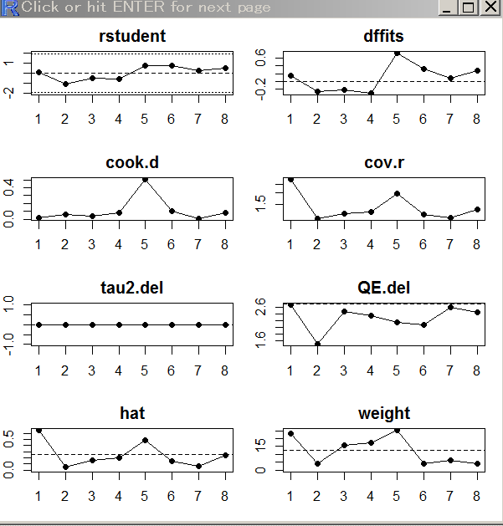

###Cumulative meta
### random-effects model
res <- rma(yi, vi, data=dat, slab=paste(author, year, sep=", "))
x <- cumul(res, order=order(dat$year))
forest(x)
forest(x, alim=c(-2,1))
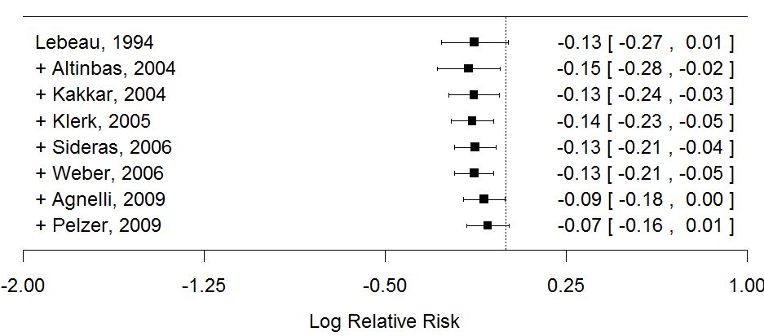

metaforは、“META-analysis FOr R”の略である。 本資料の記載は、Meta-Analysis Package for R (version 1.9-5, 2014/11/24）に準じたものである。http://www.metafor-project.org/

